**Supplementary Material for Integrated exposomic analysis of lipid phenotypes: leveraging GE.db in environment by environment association studies**

ANDRE LUIS GARAO RICO and NICOLE PALMIERO

Department of Genomics, University of Pennsylvania, 3700 Hamilton Walk  
Philadelphia, PA 19104, USA  
Email: andreluis.rico@pennmedicine.upenn.edu

MARYLYN D. RITCHIE

Department of Genomics, University of Pennsylvania, 3700 Hamilton Walk  
Philadelphia, PA 19104, USA  
Email: marylyn@pennmedicine.upenn.edu

MOLLY A. HALL

Department of Genomics, University of Pennsylvania, 3700 Hamilton Walk  
Philadelphia, PA 19104, USA  
Email: molly.hall@pennmedicne.upenn.edu

**Contents of This File**

* **Introduction**
* **Figure S-1**: Bar charts showing the sample counts by survey cycle of participants who either did or did not have cholesterol data and if they took cholesterol medications.
* **Figure S-2**: Bar chart featuring only the samples who used cholesterol medication organized by survey cycle.
* **Figure S-3**: Histograms displaying the frequencies before and after log transformation of the lipid phenotypes in the discovery and replication datasets.
* **Table S-1:** All twenty-one Bonferroni adjusted p < 0.05 significant interactions listing their p-values, sample sizes, full interaction beta, and full main-effect betas.

**Introduction**

This document provides supplementary materials for the paper titled "Integrated Exposomic Analysis of Lipid Phenotypes: Leveraging GE.db in Environment by Environment Association Studies." The supplementary materials include additional figures and tables that support the findings presented in the main paper. These materials provide further details on the data, methods, and results, including extended descriptions of results and full details of models used in the study. The data were collected from the National Health and Nutrition Examination Survey (NHANES) spanning from 1999 to 2018. Known imperfections and anomalies in the data are discussed, including the limitations of self-reported data and adjustments made for cholesterol-lowering medications.

**Figure S-1**: Bar charts showing the sample counts by survey cycle of participants who either did or did not have cholesterol data and if they took cholesterol medications.

**Figure S-2:** Bar chart featuring only the samples who used cholesterol medication organized by survey cycle.

**Figure S-3:** Histograms displaying the frequencies before and after log transformation of the lipid phenotypes in the discovery and replication datasets.

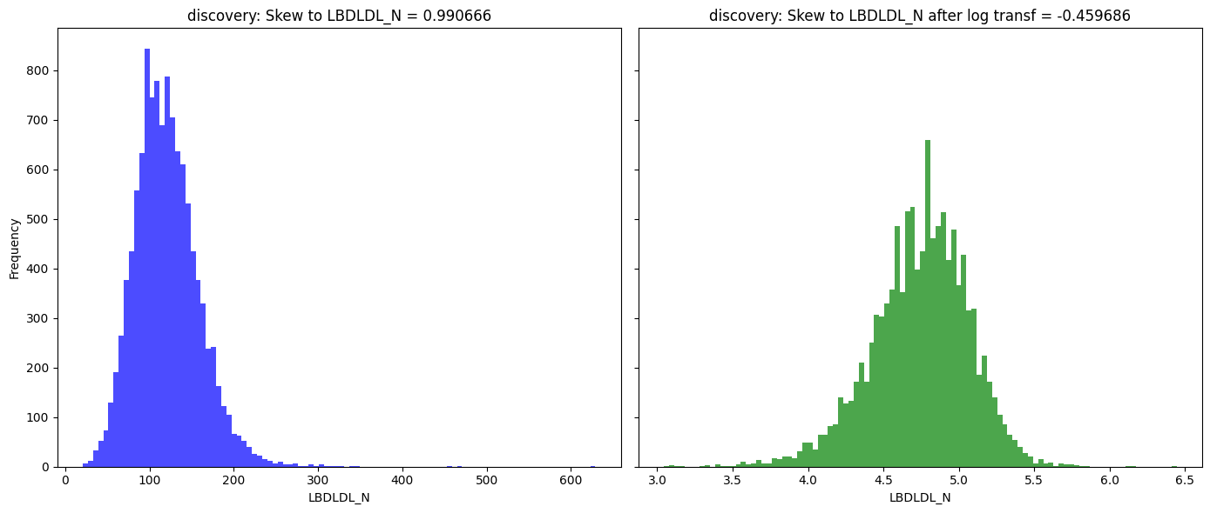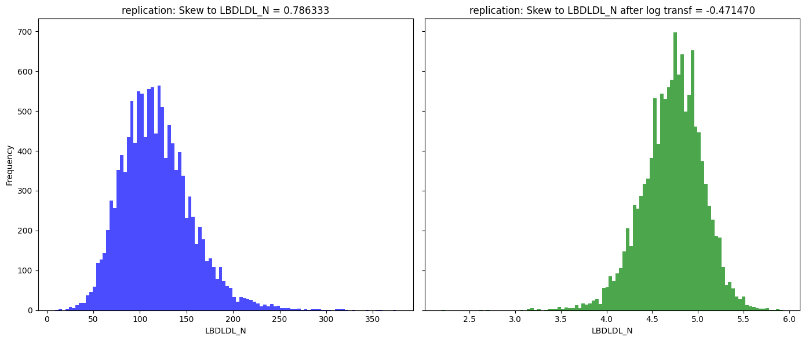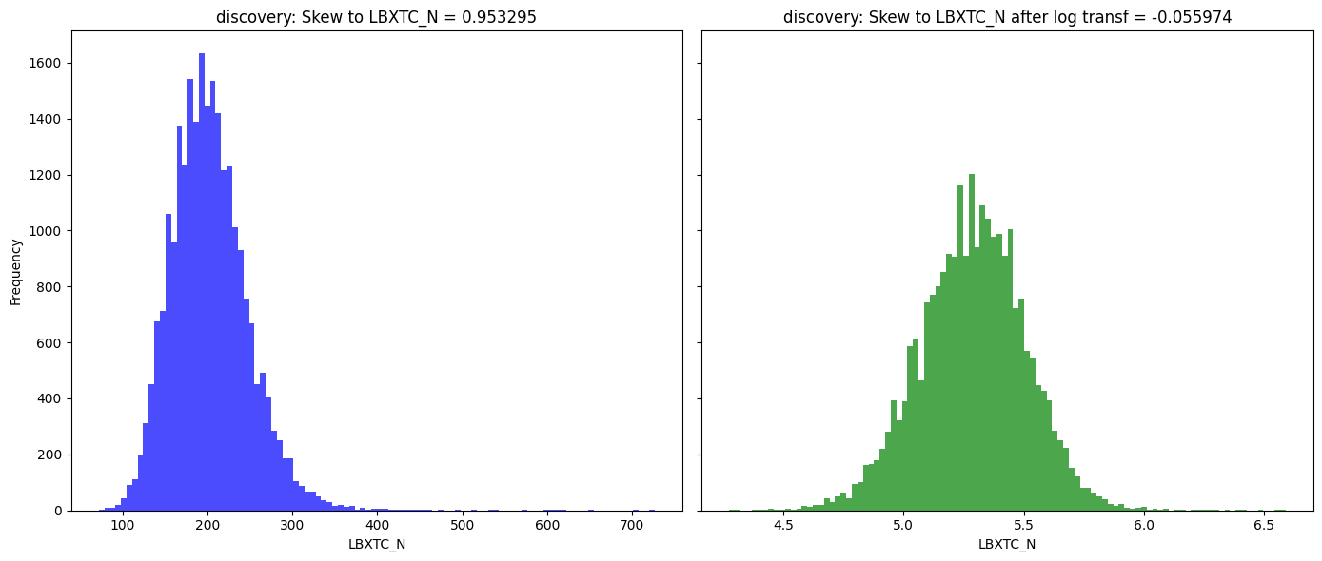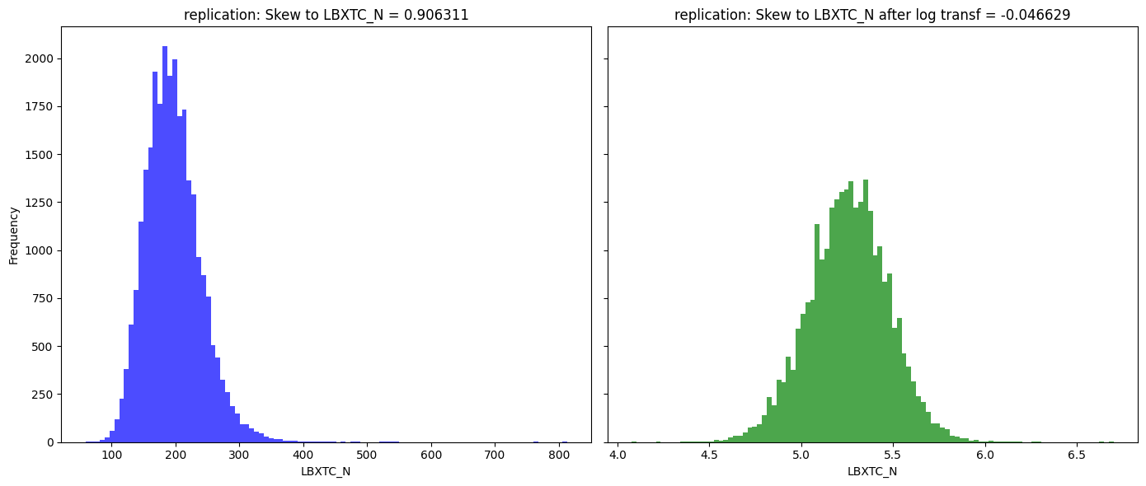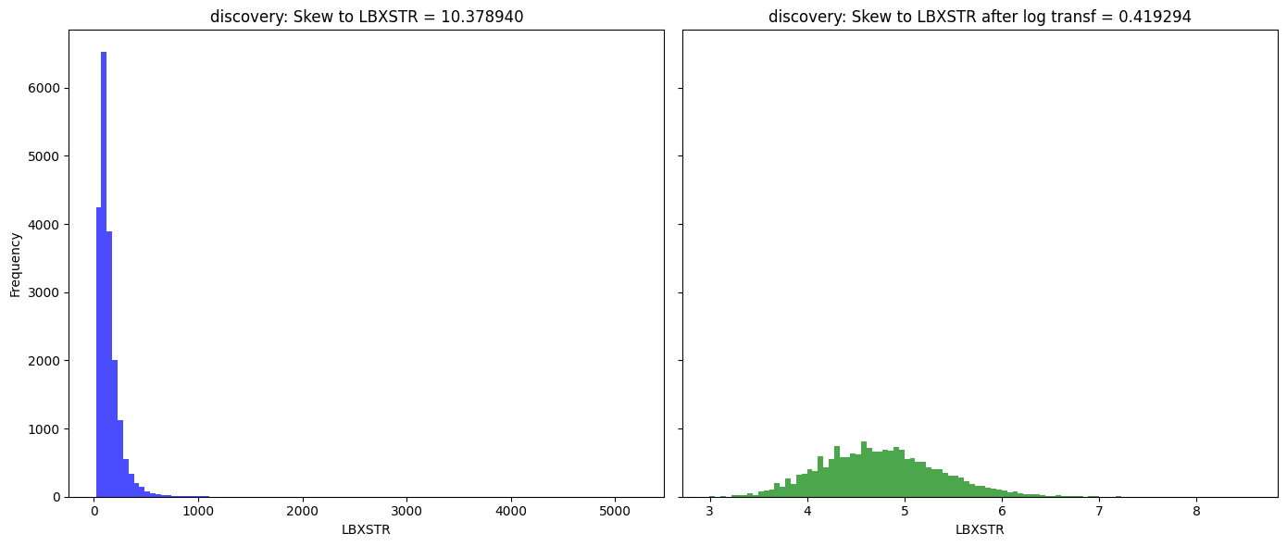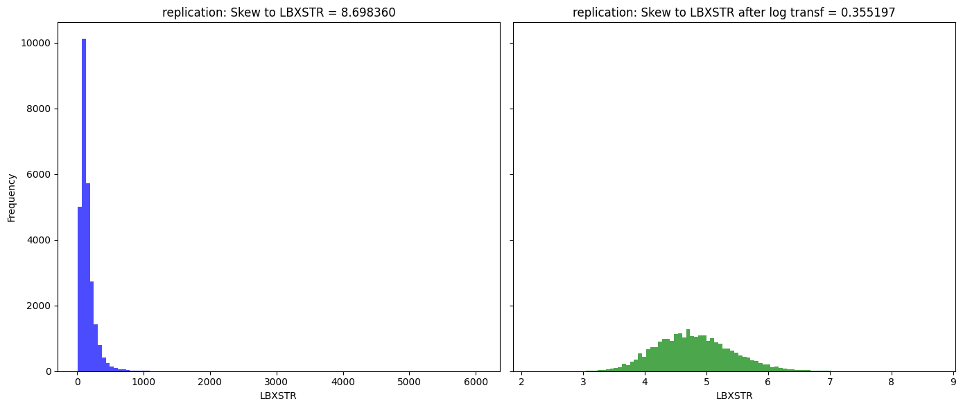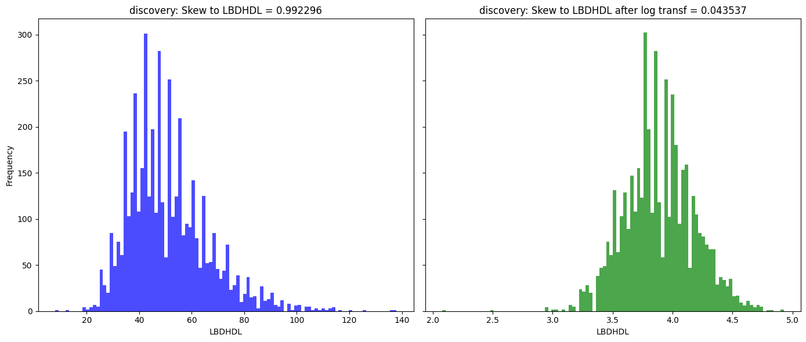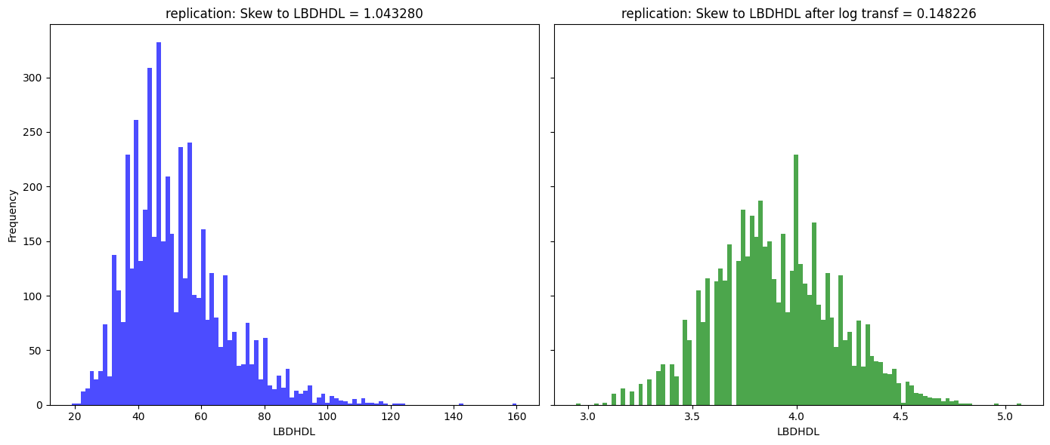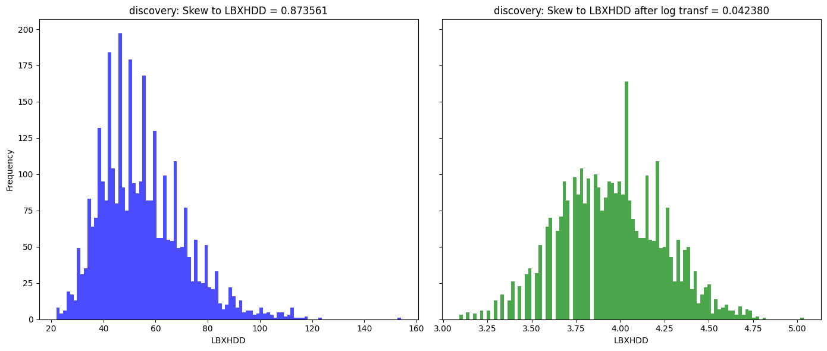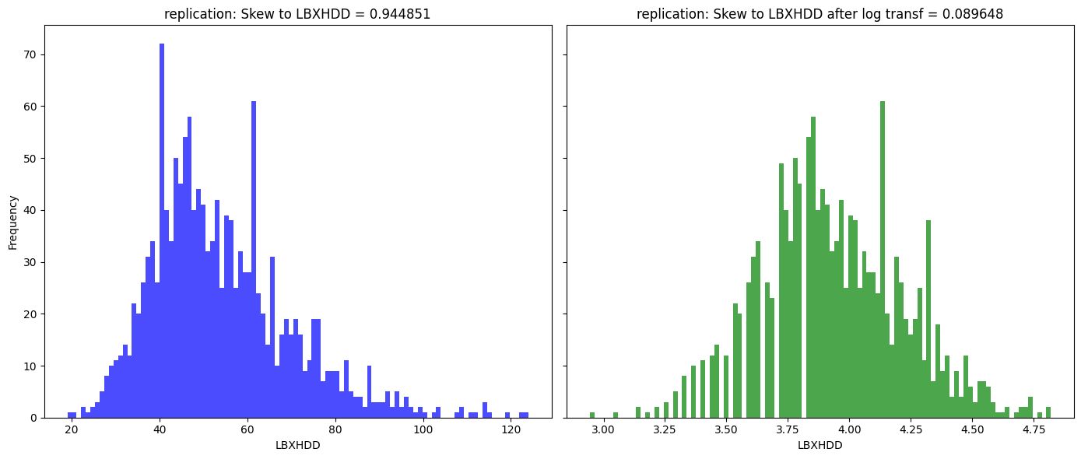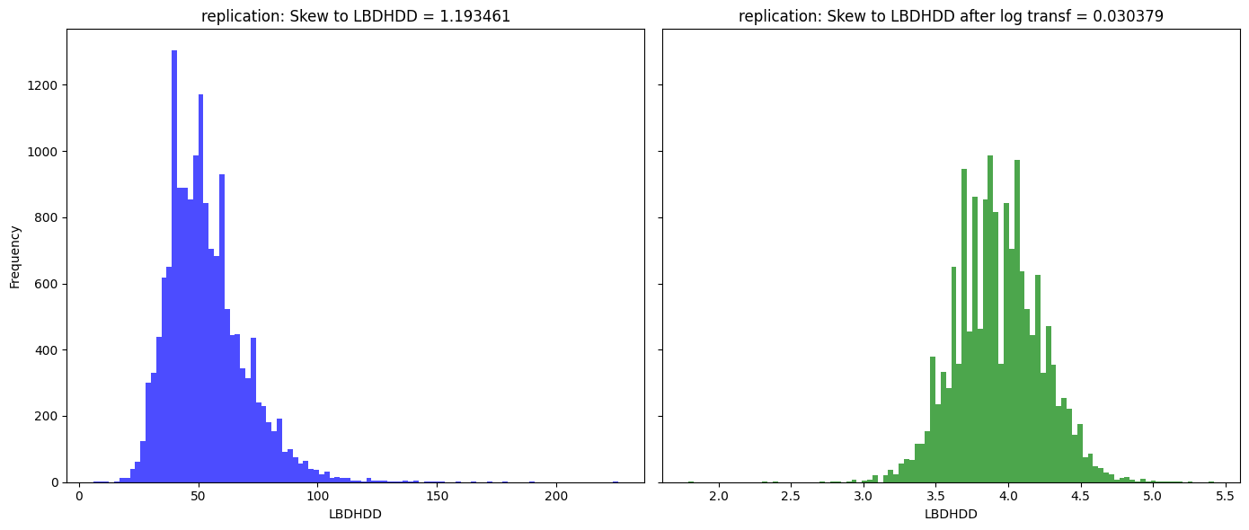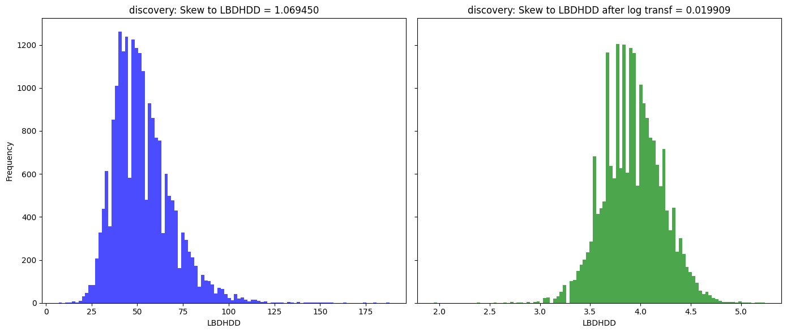

**Table S-1:** All twenty-one Bonferroni adjusted p < 0.05 significant interactions listing their p-values, sample sizes, full interaction beta and full main-effect betas.

